AI-Based Glue Route Quality Inspection for Industrial Metallic Parts

Tawfeeq, Muntadher Abdulkareem Tawfeeq

ZTE – Training Center (MMU Melaka)

2025

ABSTRACT
The manufacturing industry requires consistent and reliable quality assurance to ensure product integrity, minimize waste, and reduce production costs. One critical challenge arises in adhesive-based assembly, where the quality of glue routes significantly affects the performance and durability of industrial metallic parts. Conventional manual inspection approaches are often slow, inconsistent, and prone to human error, resulting in overlooked defects such as bubbles, uneven distribution, missing segments, or excessive glue. To address these limitations, this project introduces an AI-Based Glue Route Quality Inspection System that leverages artificial intelligence and computer vision to automate defect detection and classification. The system integrates dark-field lighting and a high-resolution global shutter camera for enhanced image acquisition, combined with a deep learning pipeline. A dataset of over 400 annotated glue route images was pre-processed and used to train a YOLOv11 detection model, achieving a mean average precision (mAP) of 80.3%. The trained model was deployed on an NVIDIA Jetson Orin Nano for edge-based inference, ensuring efficient on-site operation. To enhance usability, the model is integrated into a web-based application comprising four core modules: a home interface, an image upload function for offline detection, a live detection module to monitor glue quality in real time, and a capture-and-save function that enables the collection of new images for dataset expansion and model re-training. Experimental results show that the system effectively identifies glue defects under practical conditions, demonstrating high accuracy and robustness compared to manual inspection methods. By reducing reliance on human operators and providing real-time feedback, the proposed system improves detection consistency, scalability, and overall manufacturing efficiency. Future work will focus on enlarging the dataset, improving inference speed, and enabling continual learning for adaptive performance in dynamic production environments. This innovation demonstrates the potential of AI-driven solutions in Industry 4.0, offering manufacturers a reliable, cost-effective, and automated approach for glue route quality assurance.
Keywords: Artificial Intelligence, Glue Route Inspection, Deep Learning, YOLOv11, Industry 4.0

TABLE OF CONTENTS
Abstract 2
Table of contents 3
CHAPTER 1 INTRODUCTION 4
1.1 Overview 4
1.2 Problem Statement 5
1.3 Project Objectives 5
CHAPTER 2 METHODOLOGY 6
2.1 Overview 6
2.2 Research and Planning 6
2.3 Dataset Collection and Preprocessing 6
2.4 Model Training 8
2.5 Deployment and Application Development 8
CHAPTER 3 SYSTEM DESIGN AND IMPLEMENTATION 10
3.1 Overview 10
3.2 System Architecture 10
3.3 System Components 11
3.4 System Workflow 11
CHAPTER 4 MODEL EVALUATION 14
4.1 Overview 14
4.2 Evaluation Results 14
4.3 Future Improvements 15
CHAPTER 5 CONCLUSION 17

INTRODUCTION

Overview
In modern manufacturing industries, product quality is a critical factor that directly affects customer satisfaction, production efficiency, and overall competitiveness. Small defects that go unnoticed during inspection may lead to product failures, customer complaints, or costly recalls. For this reason, quality inspection has become an essential process in industrial production lines. Traditionally, inspection tasks have relied heavily on human operators who visually examine the products. While this approach is straightforward, it is often slow, inconsistent, and prone to human error, especially when the inspection requires attention to fine details.
With recent advances in Artificial Intelligence (AI) and Computer Vision, automated inspection systems have emerged as a reliable alternative to manual inspection. AI-based systems can analyze high-resolution images, detect defects in real time, and deliver consistent results with greater speed and accuracy. These technologies are particularly valuable in tasks where visual defects are subtle and not easily detected by the human eye.
In this project, we developed an AI-Based Glue Route Quality Inspection System to address the challenges in inspecting glue applied on industrial metallic parts. The glue route plays a critical role in ensuring the strength and sealing of the parts, and even minor defects such as bubbles, uneven thickness, or missing glue can compromise product reliability. Our system uses computer vision techniques and deep learning models to automatically analyze glue quality, distinguish between good and defective samples, and present results through an easy-to-use application interface. This solution aims to reduce dependency on human operators, increase detection accuracy, and support continuous improvement in industrial production quality.

Problem Statement
Manual glue route inspection in manufacturing is time-consuming, inconsistent, and vulnerable to human errors. Small glue defects such as bubbles, missing spots, or uneven application are difficult to detect with the naked eye, especially under high-speed production conditions. As a result, defective products may pass quality checks, leading to reduced reliability and increased maintenance or rejection costs. Therefore, there is a strong need for an automated inspection system that can perform accurate, real-time glue quality assessment with minimal human involvement.

Project Objectives
The main objectives of this project are as follows:
- To design and implement an AI-based system for automatic glue route quality inspection.

- To preprocess and analyze high-resolution images of metallic parts for glue quality evaluation.

- To train and evaluate deep learning models capable of distinguishing between good and defective glue patterns.

- To deploy the trained model on a user-friendly application for real-time inspection and decision-making.

- To support dataset expansion by capturing and saving new images for retraining and continuous improvement.

METHODOLOGY

Overview
The methodology of this project outlines the structured steps followed to design, develop, and deploy the AI-Based Glue Route Quality Inspection system. A systematic approach was necessary to ensure that the solution was effective, reliable, and adaptable for real-world manufacturing conditions. The process involved studying the problem, preparing the dataset, training and evaluating models, and finally deploying the system with a user-friendly interface. Each stage contributed to improving the accuracy and efficiency of glue route inspection.

Research and Planning
The project began with an extensive study of related works and industrial requirements. This step helped identify the key challenges in glue inspection, such as lighting conditions, small dataset size, and the difficulty of detecting subtle defects. We also explored different AI and computer vision techniques, focusing on deep learning models that have shown success in object detection tasks. After analyzing the available approaches, the YOLO family of models was selected for experimentation due to its high accuracy and fast inference speed, which are important for real-time applications.

Dataset Collection and Preprocessing
The dataset is the backbone of any AI system, and special attention was given to building a reliable dataset for this project. High-resolution images of metallic covers with glue routes were collected using an industrial camera under dark-field lighting to highlight the glue lines. The dataset included both Good samples and Not Good (NG) samples with different defect types such as bubbles, uneven glue, or missing glue.

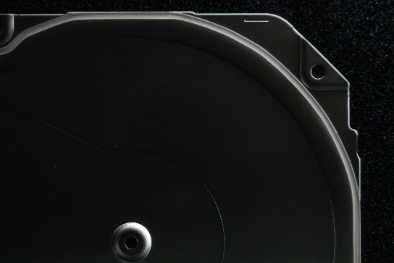  (A) | 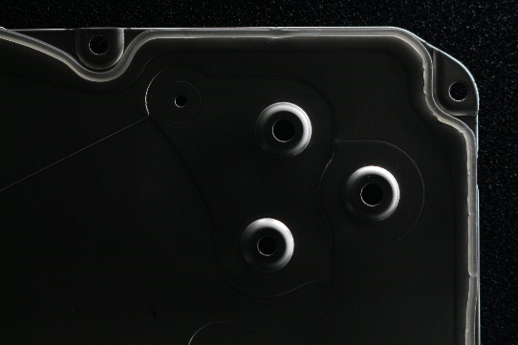  (B)
Figure 2. 1 Samples of the dataset we have collected (A) Good Glue (B) Defective Glue (Not Good)
Preprocessing was applied to enhance the clarity and consistency of the images. Techniques such as cropping, contrast enhancement, sharpening, and resizing were used to make the glue lines more visible and uniform. The images were then annotated with bounding boxes to mark glue areas and defect regions. These annotations were stored in a standard format compatible with object detection models.
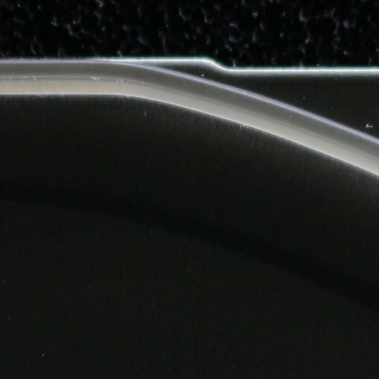  (A) | 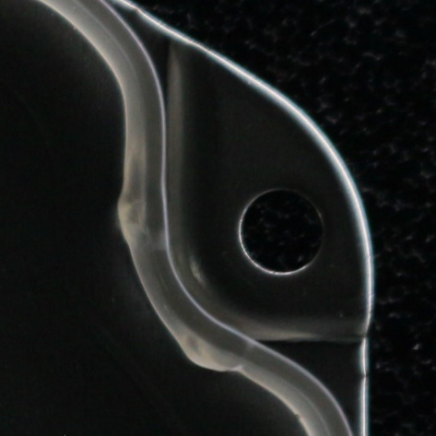  (B)
Figure 2. 2 Samples of the cropped images (A) Good Glue (B) Defective Glue (Not Good)

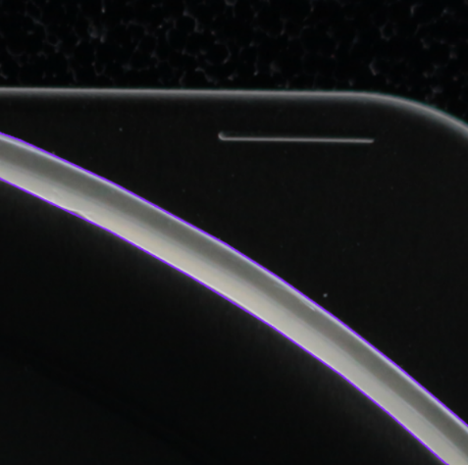  (A) | 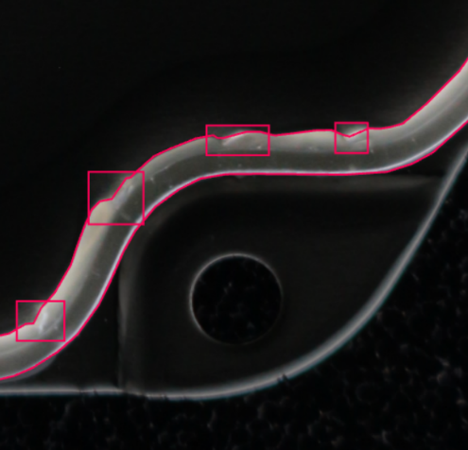  (B)
Figure 2. 3 Labeling the glue using Roboflow LabelImg tool (A) Good (B) NG

Model Training
The next stage was training deep learning models using the prepared dataset. YOLOv11 was selected as the primary model due to its balance between speed and accuracy. Training was performed in Google Colab with GPU acceleration to reduce time and improve efficiency. The dataset was divided into training, validation, and testing sets to measure the performance of the model fairly. Hyperparameters such as learning rate, batch size, and number of epochs were tuned during experiments. Data augmentation techniques (e.g., rotation, flipping, brightness adjustments) were also applied to increase dataset diversity and improve generalization.

Deployment and Application Development
After selecting the best-performing model, the next step was deployment on the NVIDIA Jetson Orin Nano, which supports real-time AI applications at the edge. A Flask-based web application was developed to provide a simple and interactive interface for the inspection system. The application includes four main pages:
- Home Page: Overview of the system and navigation.
- Upload Image Page: Allows users to upload images for inspection and view detection results.
- Live Detection Page : Performs real-time inspection using the connected camera.
- Capture & Save Page : Enables capturing new images and saving them for future dataset expansion and retraining.
This deployment ensures that the system is not only accurate but also practical for industrial usage.

SYSTEM DESIGN AND IMPLEMENTATION

Overview
This chapter presents the design and implementation of the AI-Based Glue Route Quality Inspection system. The system was designed to integrate a trained deep learning model with a practical application that can be used directly in industrial environments. The design process emphasized modularity, scalability, and usability, ensuring that each part of the system from image acquisition to final output was well structured and efficient.

System Architecture
The system follows a modular architecture, consisting of three main layers:
- Data Acquisition Layer: Responsible for capturing and uploading images of metallic covers with glue routes. Images can be obtained either from an industrial camera in live mode or uploaded manually by the user.
- AI Processing Layer: Handles the inspection of glue quality. This layer uses the trained YOLOv11 deep learning model to detect glue patterns and classify them as either “Good” or “Not Good.” The processing includes image preprocessing, model inference, and result generation.
- Application Layer : Provides a web-based interface built with Flask. It allows users to interact with the system by uploading images, performing live detection, capturing new samples, and viewing results in a simple, user-friendly format.
This layered design ensures that the system can be extended in the future, for example by retraining the model with new data or integrating additional inspection features.

System Components
Hardware Components:
- NVIDIA Jetson Orin Nano: Used as the edge computing device for running the trained AI model in real time.

- Industrial Camera: Captures high-resolution images under controlled lighting to highlight glue routes.

- Lighting Setup: Dark-field lighting was used to make the glue lines more visible and consistent.

Software Components:

- YOLOv11 Model: The deep learning algorithm trained on the dataset for defect detection.

- Flask Framework: Backend framework to integrate AI inference with the web-based application.

- HTML, CSS, JavaScript: Frontend technologies used to design the user interface.

System Workflow
The workflow of the AI-Based Glue Route Quality Inspection system is designed to provide users with a simple yet powerful way of detecting glue defects in real time. The system operates through three main front-end pages: the Upload Image Page, the Live Detection Page, and the Capture Page, all of which interact with the back-end powered by the YOLO model. Figure 3.1 illustrates the complete system workflow.
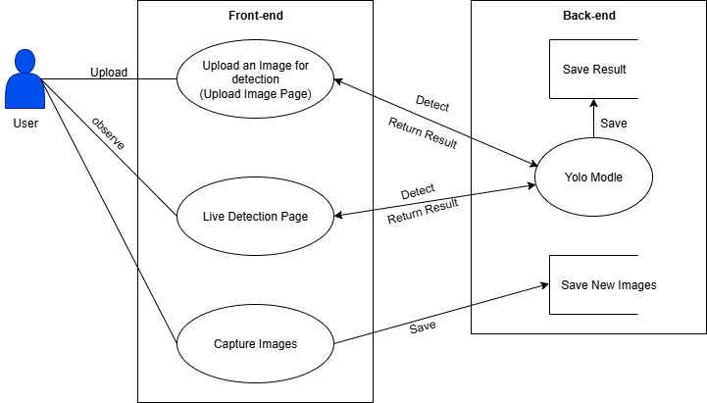
Figure 2. 4 System Workflow Diagram
When a user accesses the Upload Image Page, they can upload an image of a metallic cover containing a glue route. This image is processed by the YOLO model, which inspects the glue quality and determines whether the sample is classified as “Good” or “Not Good.” The system then saves the results and displays both the original and annotated images back to the user.
In the Live Detection Page, the system connects to the camera to provide real-time glue inspection. The live feed is analyzed frame by frame by the YOLO model, allowing users to immediately observe whether the glue is properly applied or contains defects. This feature is particularly valuable for industrial production lines where continuous monitoring is required.
The Capture Page provides an option for users to capture new images directly from the live feed. These images are saved into a designated storage folder for future use. The stored images can later be pre-processed and added to the dataset for retraining the model, which ensures continuous system improvement and adaptability to new conditions.
The back-end integrates with the front-end seamlessly by handling tasks such as running the YOLO model, saving detection results, and storing new images for retraining purposes. This modular structure makes the system scalable and suitable for long-term deployment in industrial environments.

MODEL EVALUATION

Overview
Evaluating the performance of the AI-Based Glue Route Quality Inspection system is an important step to ensure that the model can accurately detect and classify glue defects under real-world conditions. The evaluation process involved testing the trained YOLOv11 model using a separate dataset that was not included in training. This allowed us to measure the system’s ability to generalize and provide reliable inspection results.

Evaluation Results
The performance of the trained YOLOv11 model was evaluated using the testing dataset and standard object detection metrics. The confusion matrix in Figure 4.1 shows the classification performance across the three categories: Good, Not Good (NG), and Background. The model correctly classified the majority of “Good” samples, with only a small number misclassified as NG or background. For NG samples, the model achieved reasonable detection accuracy, although some defects were misclassified as background, which suggests that certain defect features remain challenging to detect.
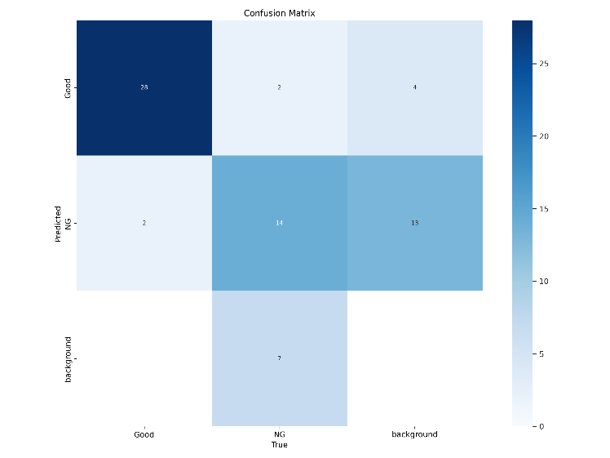
The training and validation results are presented in Figure 4.2. The graphs illustrate the reduction of box loss, classification loss, and distribution focal loss over the epochs, demonstrating that the model successfully learned from the dataset. Meanwhile, the precision and recall metrics showed a steady improvement as training progressed. The mAP50 metric (mean Average Precision at 50% IoU) reached a high value, confirming strong detection accuracy, while mAP50-95 also improved, reflecting the model’s ability to perform well across stricter IoU thresholds.
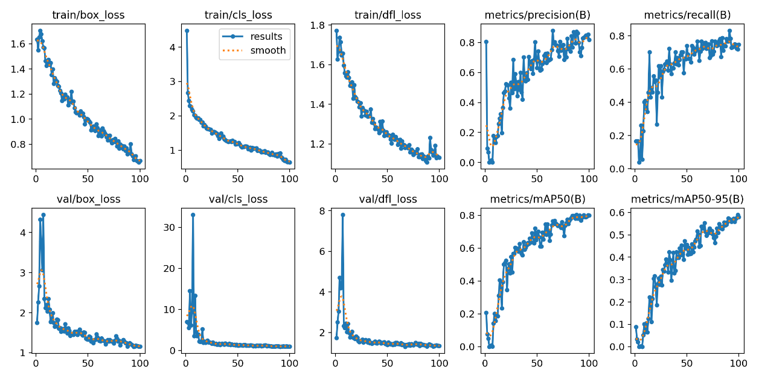
Overall, the model achieved an mAP of 80.3%, with balanced precision and recall, making it suitable for real-time deployment in glue route inspection. The evaluation confirmed that the system can effectively identify both good and defective glue routes under controlled lighting conditions.

Future Improvements
While the evaluation shows promising results, there are areas where the model and system can be improved:
- Expand the Dataset: Increasing the size and diversity of the dataset, especially with more samples of defective glue (bubbles, missing glue, uneven lines), will enhance model robustness and reduce misclassifications.
- Improve Lighting Conditions: Although dark-field lighting improves visibility, variations in lighting can still affect performance. Experimenting with multiple lighting setups or applying adaptive preprocessing methods could improve detection in different environments.

- Data Augmentation: Applying more advanced augmentation techniques such as random noise addition, blur simulation, or synthetic defect generation could help the model generalize better to unseen conditions.

- Model Optimization: Using pruning or quantization techniques can reduce computational load on the Jetson Orin Nano, allowing faster inference without losing accuracy.

- Continuous Learning: The Capture & Save Page can be fully integrated into an active learning pipeline. Captured images can be periodically annotated and used to retrain the model, ensuring that the system continuously adapts to new glue patterns and defect types.

- Alternative Models: Exploring other state-of-the-art object detection models such as YOLOv12, RetinaNet, or Mask R-CNN could provide improved accuracy or segmentation-based defect localization.

CONCLUSION
This project presented the design and development of an AI-Based Glue Route Quality Inspection System for industrial metallic parts. The motivation was to address the limitations of manual inspection, which is often slow, inconsistent, and prone to human error. By applying computer vision and deep learning, the system provides a reliable and efficient alternative that can operate in real time.
The methodology followed a structured process, beginning with dataset collection and preprocessing, followed by model training and evaluation, and finally deployment on the NVIDIA Jetson Orin Nano with a user-friendly web application. The dataset was prepared using dark-field lighting to highlight glue routes, and images were carefully annotated into “Good” and “Not Good” categories. The YOLOv11 model was selected after experimentation with multiple configurations, achieving an mAP of 80.3% and balanced precision and recall. These results demonstrate the system’s effectiveness in detecting glue defects such as bubbles, missing glue, and uneven lines.
The deployed application provides three main functionalities: Upload Image Page for inspection of uploaded images, Live Detection Page for real-time monitoring, and Capture Page for saving new images to expand the dataset. This structure not only ensures accurate inspection but also supports continuous improvement through retraining with new data.

